

FAT and NTFS image recovery

Jordan Sosnowski, Demarcus Campbell, Grant Pinkert
March 1, 2019

Executive Summary
We were tasked with analyzing two different disk image files: FAT.dd and FTFS.dd. With these images, we found the number of partitions and attempted to find existing and deleted files. For each file, we specified the hexadecimal address while also generating the FATs for the FAT image and we found the file attributes of each file in the NTFS image. We were able to recover several JPEG images as well as several PDFs while identifying several deleted files and subsequently recovering those as well.

Table of Contents
Executive Summary 2
List of Figures 4
List of Tables 6
1 Introduction 7
2 FAT Image 8
2.1 SEC PICS 9
2.2 CLASSICS 21
3.3 GIFS 25
3 NTFS Image 29
5 Conclusion 41
6 References 41

List of Figures
Figure 1 – Active Disk Editor Partition Records Master Boot Record Example 8
Figure 2 - Fdisk Example 9
Figure 3 - Active Disk Editor FAT Reserved Sector 10
Figure 4 - FAT Format 11
Figure 5 - FAT Entry 12
Figure 6 - User File Tennesse.JPG 14
Figure 7 - FAT Directory Entry 15
Figure 8 - FAT Directory Entry 15
Figure 9 - FAT Directory Entry 15
Figure 10 - FAT Directory Entry 16
Figure 11 - FAT Directory Entry 16
Figure 12 - FAT Directory Entry 16
Figure 13 - FAT Directory Entry 16
Figure 14 - FAT Directory Entry 17
Figure 15 - fsstat Example 19
Figure 16 - fls Example 20
Figure 17 - istat Example 20
Figure 18 - Disk Editor 22
Figure 19 - FAT Structure 22
Figure 20 - Great Expectations 23
Figure 21 - Pride and Predjudice 24
Figure 22 - War and Peace 24
Figure 23 - Tale of Two Cities 24
Figure 24 - NTFS MBR using FTK Imager 30
Figure 25 - File Fragmentation Recovery 40

List of Tables
Table 1 - FAT Information 10
Table 2 - FAT Offsets 10
Table 3 List of clusters and the cluster entry 13
Table 4 - FAT File Recovery 18
Table 5 - FAT Partition 2 Recovery 25
Table 6 - FAT Partition 3 File Recovery 28
Table 7 - NTFS File Recovery 39

1 Introduction
For this project we were given two image files, FAT.dd and NTFS.dd. With these files, we were tasked with finding out the details of each image. For both the FAT image and the NTFS image we were to find out the starting hexadecimal storage address. This address is needed because with each image, there is a small offset in the beginning with some image information, such as the partitions, the partition types, etc. which is needed to find out where each partition starts.
For the FAT image, we needed to generate the File Allocation Table. This table is comprised of a map showing where the clusters in the data area is located as well as how many active files are in the partition. After that we can go to the root directory, here we will find information about the file’s name, size, if its deleted, etc. From the information found in the FAT and root directory we can locate the file in the data area and attempt to recover it.
For the NTFS image, we will need to find the Master File Table start sector. At the beginning of the MFT there are a few system files, each MFT entry is 1024 bytes. If we jump past a few entries, we will eventually find user files. Here, just like other MFT entry the entry is made up of file attributes. Using the values of the file attributes we can find the file name, file creation time, and even the file data itself.
After grabbing all these values for the various partitions and images we can finally attempt to recover the files. Deleted files are recovered just like the normal files. However, some deleted and active files are fragmented and are unable to be recovered using the normal process we would use for DD, to recover them it is easier to use icat.

2 FAT Image
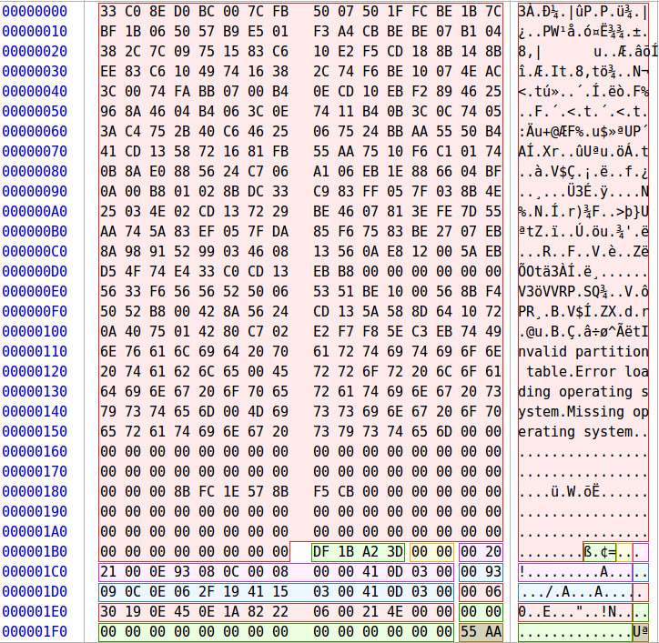
Figure 1 – Active Disk Editor Partition Records Master Boot Record Example
Using Active Disk Editor, we can find the start of each partition. Partition I’s first sector is located at 2048 (offset 0x1C6 from the beginning of the image). Partition II’s first sector is located at 202,049 (offset 0x1D6). Partition III’s first sector is located at 402,050 (offset 0x1E6). We can also see each partition file system ID’s located at 0x01C2, 0x01D2, 0x01E2 respectively. They are all 0x0E which symbolizes FAT16.
Now that we have their sector locations, we need the offset in bytes. To calculate this, you need to multiply the sector by the value of bytes per sectors, we will assume the sector per byte count is 512. Partitions in this image are located at the following address:
- Partition I: 2048 * 512 = 1,048,576
- Partition II: 202,049 * 512 = 103,449,088
- Partition III: 402,050 * 512 = 205,849,600
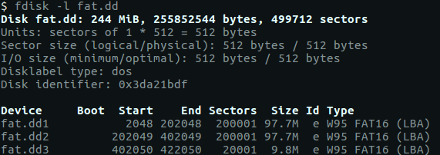
Figure 2 - Fdisk Example
We can corroborate this information by using the tool fdisk. Using fdisk with the switch ‘l’ and the image’s path it will list the disks partitions and information about it. As you can see each sector is sized 512 bytes and that the partitions start at the values that we got from the hex dump.

2.1 SEC PICS
We will not actually view the raw image in Active Disk Editor, but instead view each partition individually. This will make the address smaller due to the fact that the partitions offsets are not being added. We will have to add each partition's offset back when recovering the files however. That aside we will go to the first FAT Partition SEC PICS. This will bring us to the first reserved sector of the FAT partition. Here we can grab: bytes/sector, sectors/cluster, reserved sectors, number of fats, root entries, and total sectors.

Table 1 - FAT Information | Table 2 - FAT Offsets
  Name | Offset | Value
  Bytes/sector | 0x00B | 512
  Sectors/cluster | 0x00D | 4
  Number of FATs | 0x010 | 2
  Root Entries | 0x011 | 512
  Name | Offset | Value
  Total Sectors [small] | 0x013 | 0
  Sectors Per FAT | 0x016 | 195
  Total Sectors [large] | 0x020 | 200,001

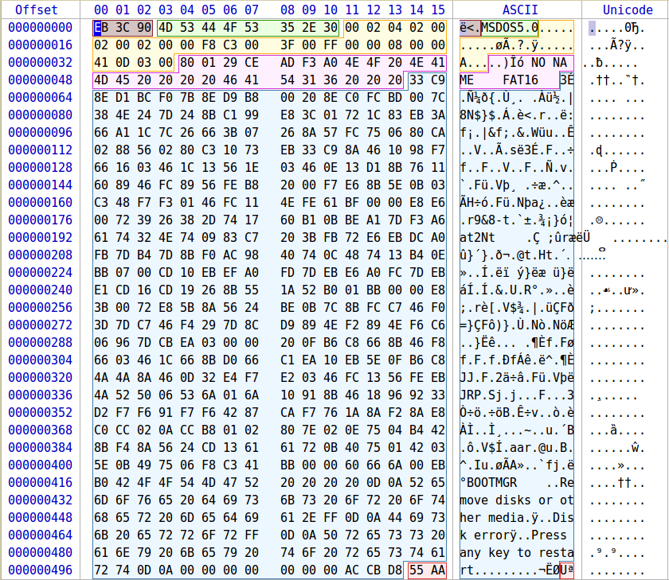
Figure 3 - Active Disk Editor FAT Reserved Sector
With the information we gathered above we can create a layout for the FAT structure. We know that the reserved sectors consist of 2 sectors, each FAT is 195. However, we do not know inherently how big the root directory is. However, we do have how many entry’s we have in the root and we know that each entry is always 32 bytes. We know that the root directory is 16,384 total bytes (512 entries * 32 bytes) and from that we know that its 32 sectors long (16,384 bytes / 512 bytes/sector). We also know that there is a total of 200,001 sectors and we know where the root directory ends (reserved sector + 1st FAT + 2nd FAT + Root) which is 424. To get the size of the data area we can subtract 200,001 from 424 which gives us 199,579 sectors for the Data Area, and it starts at 424. From this information we can generate the image below.
2 | 195 | 195 | 32 | 199,577
Reserved Sectors | 1st FAT Area | 2nd FAT Area | Root Directory | Data Area
0-1 | 2-196 | 197-391 | 392-423 | 424-200,000
Figure 4 - FAT Format
After generating the layout of the partition, we will go to the 1st FAT area to see how the clusters are allocated. The first FAT is located at sector 2, which in bytes is 1024 (0x400). At that location we see the below image. For FAT16 each cluster takes up two bytes in the FAT. The first two entries are special values. The first entry in the FAT is the FAT ID, 0xF0 indicates a volume on a non-partition supper floppy drive, and 0xF8 for partitioned disks [1]. The second entry is the end of chain indicator, so for this FAT 0xFFFF marks the end of a chain.
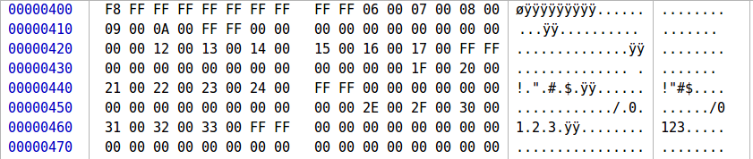
Figure 5 - FAT Entry

After these special entries start actual files. The first few files on a partition are usually system files but we cannot always assume that. However, we can create the chart listed below from FAT. The green entries are user files that are active. The blue entries are empty clusters, which may or may not contain deleted files. The black entries are the special entries, and the orange ones are assumed to be system files. Which we can validate later in the root directory. After analyzing the FAT, we can go to the root directory.

Table 3 List of clusters and the cluster entry
  Cluster | Next Cluster
  0x0000 | 0xFFF8
  0x0001 | 0xFFFF
  0x0002 | 0xFFFF
  0x0003 | 0xFFFF
  0x0004 | 0xFFFF
  0x0005 | 0x0006
  0x0006 | 0x0007
  0x0007 | 0x0008
  0x0008 | 0x0009
  0x0009 | 0x000A
  0x000A | 0xFFFF
  0x000B | 0x0000
  0x000C | 0x0000
  0x000D | 0x0000
  0x000E | 0x0000
  0x000F | 0x0000
  0x0010 | 0x0000
  0x0011 | 0x0012
  0x0012 | 0x0013
  0x0013 | 0x0014
  0x0014 | 0x0015
  0x0015 | 0x0016
  0x0016 | 0x0017
  0x0017 | 0xFFFF
  0x0018 | 0x0000
  0x0019 | 0x0000
  Cluster | Next Cluster
  0x001A | 0x0000
  0x001B | 0x0000
  0x001C | 0x0000
  0x001D | 0x0000
  0x001E | 0x001F
  0x001F | 0x0020
  0x0020 | 0x0021
  0x0021 | 0x0022
  0x0022 | 0x0023
  0x0023 | 0x0024
  0x0024 | 0xFFFF
  0x0025 | 0x0000
  0x0026 | 0x0000
  0x0027 | 0x0000
  0x0028 | 0x0000
  0x0029 | 0x0000
  0x002A | 0x0000
  0x002B | 0x0000
  0x002C | 0x0000
  0x002D | 0x002E
  0x002E | 0x002F
  0x002F | 0x0030
  0x0030 | 0x0031
  0x0031 | 0x0032
  0x0032 | 0x0033
  0x0033 | 0xFFFF

Based on the table we created earlier the root directory starts at sector 392, or byte 200,704 (0x31000). The root table shows us directory entries, as well as all files, even those that are marked as deleted. Here, we find the filename, extension, attribute, modify date, cluster, and the file size, all of which is to be used to extract the file. At the root directory we see this. As stated early each listing in the root directory is 32 bytes long. As we assumed earlier the first 3 entries are system entries. At the fourth entry we can see the user file Tennesse.JPG
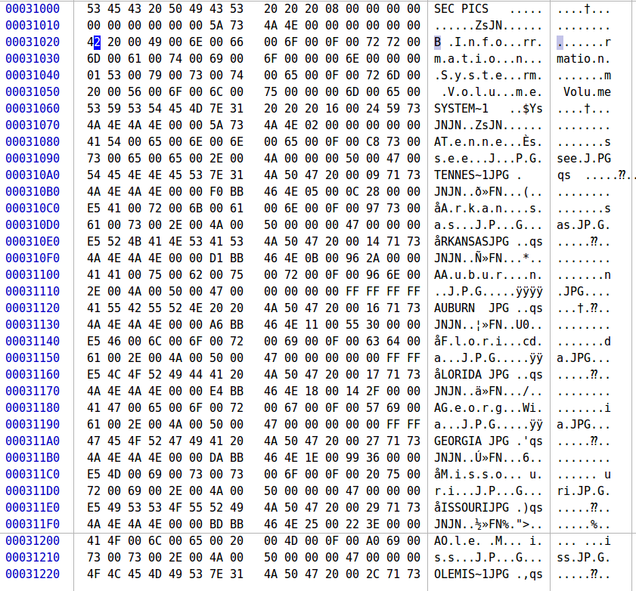
Figure 6 – Root Directory Entry

Each short entry will follow the same format. The entries prior to the short entries are long entries, which contain the full length of the filename if the short entry cannot hold it. From the short entries we can gather the following: file status, filename, file extension, attribute, modified date/time, starting cluster, and file size. With this information we can attempt to locate the individual files in the data area and hopefully recover them.
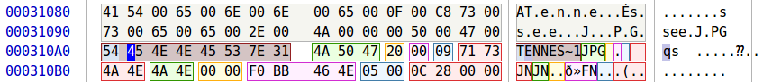
Figure 7 - FAT Directory Entry
- Tennessee
  - Status: 0x41 – Normal
  - Filename: Tennessee
  - Extension: JPG
  - Attribute: 0x20 – Archive
  - Modified date/time: 2/6/19 11:31 PM
  - Cluster: 0x0005 – 5
  - File Size: 0x0000280C – 10,252 bytes
Figure 8 - FAT Directory Entry
- Arkansas
  - Status: 0xE5 – Deleted
  - Filename: Arkansas
  - Extension: JPG
  - Attribute: 0x20 – Archive
  - Modified date/time: 2/6/19 11:30 PM
  - Cluster: 0x000B – 11
  - File Size: 0x00002A96 – 10,902 bytes
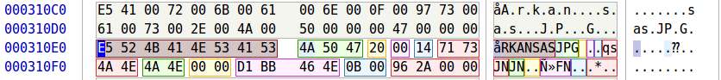
Figure 9 - FAT Directory Entry
- Auburn
  - Status: 0x41 – Normal File
  - Filename: Auburn
  - Extension: JPG
  - Attribute: 0x20 – Archive
  - Modified data/time: 2/6/19 11:29 PM
  - Cluster: 0x0011 – 17
  - File Size: 0x00003055 – 12,373 bytes
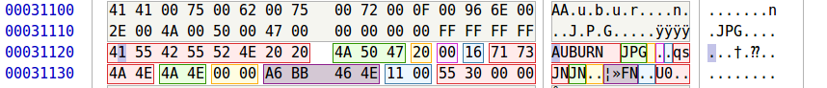
Figure 10 - FAT Directory Entry
- Florida
  - Status: 0xE5 – Deleted
  - Filename: Florida
  - Extension: JPG
  - Attribute: 0x20 – Archive
  - Modified date/time: 2/6/19 11:31 PM
  - Cluster: 0x0018 – 24
  - File Size: 0x00002F14 – 12,052
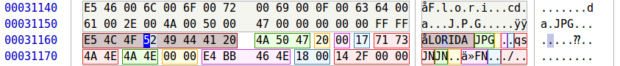
Figure 11 - FAT Directory Entry
- Georgia
  - Status: 0x41 – Normal File
  - Filename: Georgia
  - Extension: JPG
  - Attribute: 0x20 – Archive
  - Modified date/time: 2/6/19 11:30 PM
  - Cluster: 0x001E – 30
  - File size: 0x00003699 – 13,977 bytes
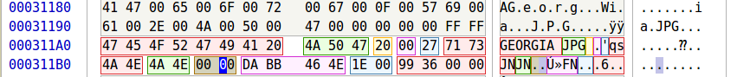
Figure 12 - FAT Directory Entry
- Missouri
  - Status: 0xE5 – Deleted
  - Filename: Missouri
  - Extension: JPG
  - Attribute: 0x20 – Archive
  - Modified date/time: 2/6/19 11:29 PM
  - Cluster: 0x0025 – 37
  - File size: 0x00003E22 – 15,906 bytes
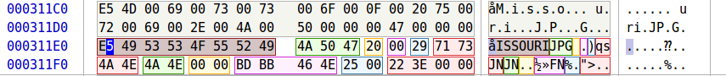
Figure 13 - FAT Directory Entry
- Ole Miss
  - Status: 0x41 – Normal File
  - Filename: Ole Miss
  - Extension: JPG
  - Attribute: 0x20 – Archive
  - Modified date/time: 2/6/19 11:30 PM
  - Cluster: 0x002D – 45
  - File size: 0x0000339B – 13,211 bytes
Figure 14 - FAT Directory Entry
Using all the information, now it is possible to recover the files. To get a file, we use the dd command as follows:
sudo dd if=image_name of=filename bs=block_size skip=blocks_to_skip count=blocks_to_grab
The skip value is the starting position of the file. This is found by finding the cluster number for whichever file, subtracting two from it, multiplying that value by the value of bytes per cluster (cluster offset), then adding the cluster offset to data offset (file offset), and then adding that to partition offset (actual offset). Using the root directory entry, we can then find the length of the file of bytes, which is used for the count argument. Block size is set to 1 in case a file does not end up using full sectors or clusters. Using the above information, we can get this table. If the commands were run in a terminal with the current directory hosting the fat.dd image the files would be correctly retrieved.

Table 4 - FAT File Recovery
Filename | Cluster | File Length | Cluster Offset | File Offset | Actual Offset | Command to Retrieve File
Tennessee.JPG | 5 | 10,252 | 6,144 | 223,232 | 1,271,808 | sudo dd if=fat.dd of='Tennessee.JPG' bs=1 skip=1271808 count=10252 status=progress
Arkansas.JPG | 11 | 10,902 | 18,432 | 235,520 | 1,284,096 | sudo dd if=fat.dd of='Arkansas.JPG' bs=1 skip=1284096 count=10902 status=progress
Auburn.JPG | 17 | 12,373 | 30,720 | 247,808 | 1,296,384 | sudo dd if=fat.dd of='Auburn.JPG' bs=1 skip=1296384 count=12373 status=progress
Florida.JPG | 24 | 12,502 | 45,056 | 262,144 | 1,310,720 | sudo dd if=fat.dd of='Florida.JPG' bs=1 skip=1310720 count=12502 status=progress
Georgia.JPG | 30 | 13,977 | 57,344 | 274,432 | 1,323,008 | sudo dd if=fat.dd of='Georgia.JPG' bs=1 skip=1323008 count=13977 status=progress
Missouri.JPG | 37 | 15,906 | 71,680 | 288,768 | 1,337,344 | sudo dd if=fat.dd of='Missouri.JPG' bs=1 skip=1337344 count=15906 status=progress
Ole Miss.JPG | 45 | 13,211 | 88,064 | 305,152 | 1,353,728 | sudo dd if=fat.dd of='Ole Miss.JPG' bs=1 skip=1353728 count=13211 status=progress

We can corroborate all the information we found with a Sleuth Kit, which is a collection of digital forensics tools, that essentially do all the work we did in a few lines. The first command we will want to use is mmls <image>. This will give us information about the volume’s partitions. However we have already ran an equivalent command to that with fdisk -l, so we will skip it. The next command we will want to run is fsstat which gives us information about the file system. Running fsstat -o 2048 fat.dd will give us information about the first partition.

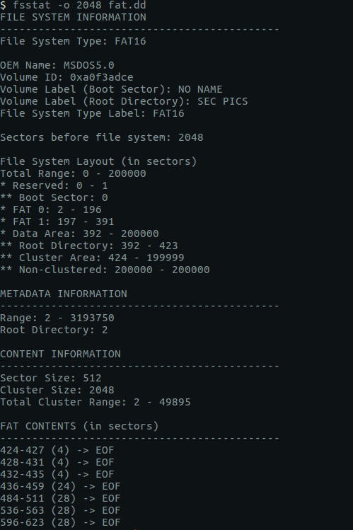
Here we can see that our findings about the first FAT partition, SEC PICS, match up exactly.

The next command we will want to run is fls. This command will list file and directory names in the disk image. Note just like for fsstat we will have to give an offset to the correct partition.

Figure 15 - fsstat Example
Running fls -o 2048 fat.dd we get the following information
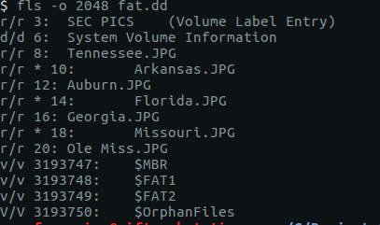
Figure 16 - fls Example
Here we can see the information about the file’s names, if they are deleted, and their inodes. Using istat, which gives us details about meta-data structures (i.e. inode), we can print out information about the specific file. Using istat -o 2048 fat.dd 10, we can preview information about Arkansas.JPG.
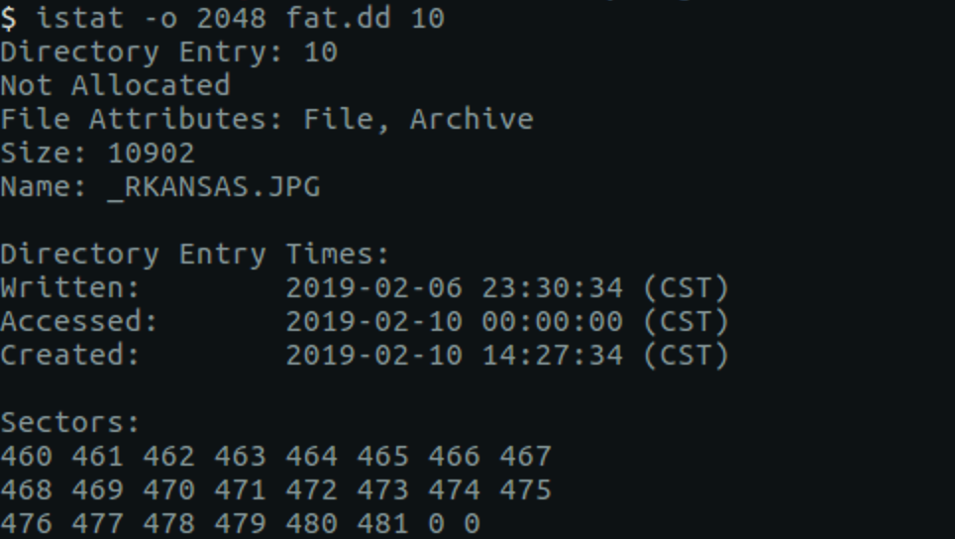
Figure 17 - istat Example

2.2 CLASSICS
The same methodology can be applied to other FAT Partitions. What follows will just be a quick rundown of the values found in the classics partition instead of a detailed analysis.
- Structure Size Calculations
  - Partition Offset = 0x62A8200 = 103,449,088 bytes
  - Bytes / Sector
    - Offset 0x0B = 0x0200 = 512
  - Sectors / Cluster
    - Offset 0x0D = 0x4 = 4
  - Bytes / Cluster
    - 4 Sectors / Cluster * 512 Bytes / Sector = 2048
  - Reserved Sectors
    - Offset 0x000E = 0x0002 = 2
  - Number of FATs
    - Offset 0x0010 = 0x02 = 2
  - 1st FAT Area Size
    - Offset 0x0016 = 0x00C3 = 195 sectors
  - 2nd FAT Area Size
    - Offset 0x0016 = 0x00C3 = 195 sectors
  - Root Directory
    - Directory Entries
      - Offset 0x0011 = 0x0200 = 512 entries
    - 512 * 32 bytes = 16,384 bytes / 512 (bytes/sector) = 32 sectors
  - Data Area
    - Total Sectors
      - Offset 0x0020 = 0x00030D41 = 200,001 Sectors
    - Data Area = Total Sectors – End of Root
      - 200,001 – 424 = 199579 Sectors
Figure 18 - Disk Editor
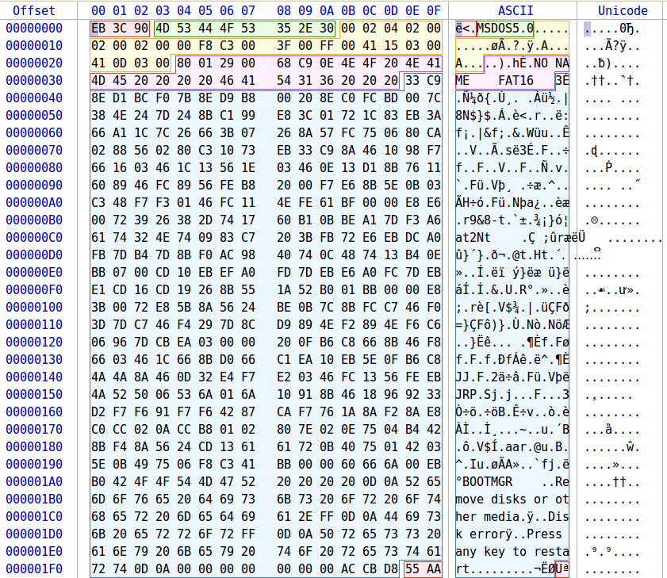

- FAT Structure
Figure 19 - FAT Structure
2 | 195 | 195 | 32 | 199,577
Reserved Sectors | 1st FAT Area | 2nd FAT Area | Root Directory | Data Area
- File Allocation Table
  - Located from sector 2 – 196
  - Bytes 1024 – 100,352
  - Address 0x400 – 0x18800

Cluster | Next Cluster
0x0000 | 0xFFF8
0x0001 | 0xFFFF
0x0002 | 0xFFFF
0x0003 | 0xFFFF
0x0004 | 0xFFFF
0x0005 | 0x0006
0x0006 | 0x0007
0x0007 | 0x0008
0x0009 | 0x000A
...
0x061B | 0x061C
0x061C | 0xFFFF
0x0000 | 0x000
…
0x000 | 0x000
As you can see this FAT table is slightly different than the one earlier. This one only has one linked list while the other had four separated by three lists of zeros. This table however has one list of allocated clusters and a large list of zeros. What this means is that there is one allocated file, and the rest of it is unallocated space. There could be one massive deleted file in that list of zeros or multiple deleted files, or no deleted files at all. All we know at this point is there is one large allocated file, and a large set of unallocated clusters.

- Root Directory Structure
  - Sector 392 – 423
  - Byte 200,704 – 216,576
  - Address 0x31000 – 0x34E00
- Root Directory Entries
  - Great Expectations
    - Status: 0x42
    - Filename: Great Expectations
    - Extension: PDF
    - Attribute: 0x20 – Archive
    - Modified date/time: 2/10/19 2:28 PM
    - Cluster: 0x0005 – 5
    - File Size: 0x0000280C – 3,193,980 bytes
Figure 20 - Great Expectations
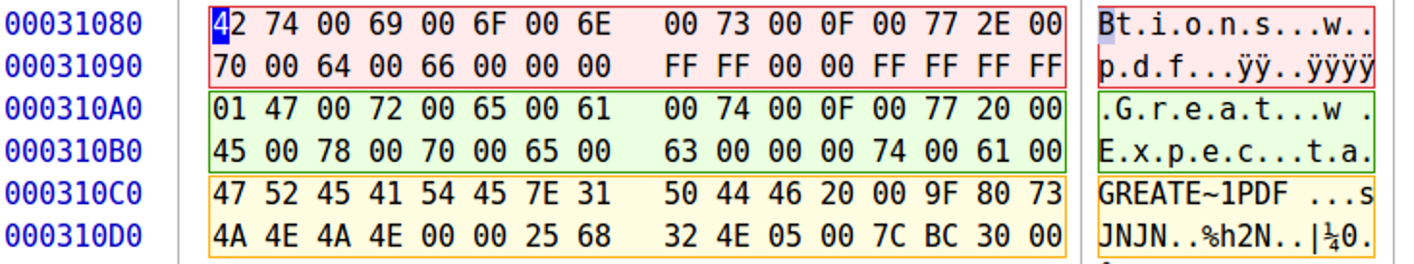

  - Pride and Prejudice
    - Status: 0xE5 – Deleted
    - Filename: Pride and Prejudice
    - Extension: PDF
    - Attribute: 0x20 – Archive
    - Modified date/time: 1/18/19 1:01 PM
    - Cluster: 0x061D – 1,565
    - File Size: 0x000C303B – 798,779 bytes
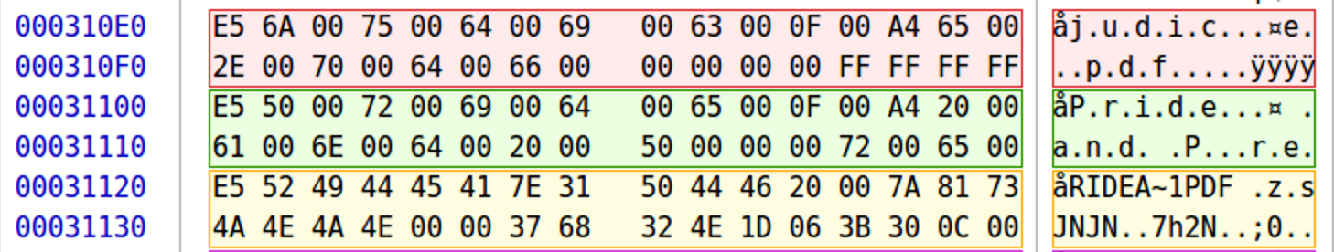
Figure 21 - Pride and Predjudice
  - War and Peace
    - Status: 0xE5 – Deleted
    - Filename: War and Peace
    - Extension: PDF
    - Attribute: 0x20 – Archive
    - Modified date/time: 2/10/19 11:15 AM
    - Cluster: 0x07A4 – 1956
    - File Size: 0x009BC0F7 – 10,207,479
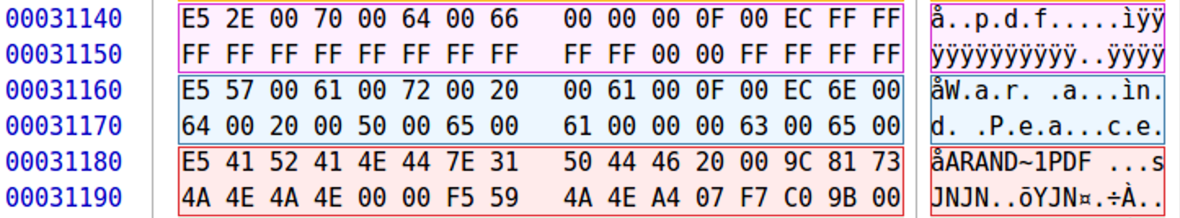
Figure 22 - War and Peace
  - Tale of Two Cities
    - Status: 0xE5 – Deleted
    - Filename: Tale of Two Cities
    - Extensions: PDF
    - Attribute: 0x20 – Archive
    - Modified date/time: 1/18/19 12:58 PM
    - Cluster: 0x1B1D – 6,941
    - File Size: 1,316,140 bytes
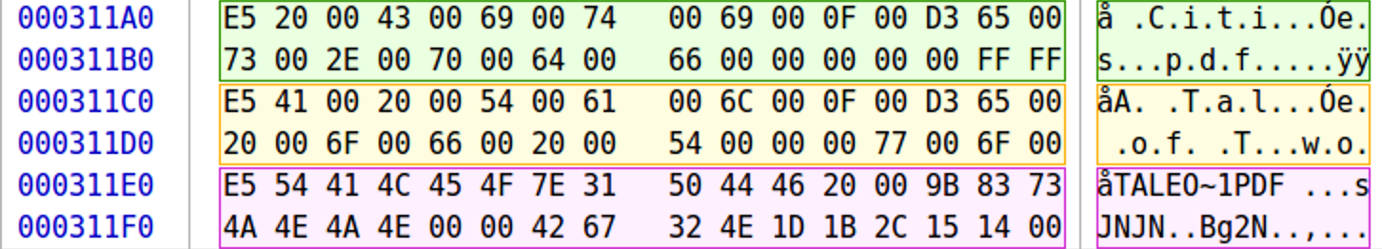
Figure 23 - Tale of Two Cities

- File Recovery

Table 5 - FAT Partition 2 Recovery
Filename | Cluster | File Length | Cluster Offset | File Offset | Actual Offset | Command To Retrieve File
Great Expectations.pdf | 5 | 3,193,980 | 6144 | 223,232 | 103,672,320 | sudo dd if=fat.dd of= ‘Great Expectations.pdf' bs=1 skip=103672320 count=3193980 status=progress
Pride and Prejudice.pdf | 1,565 | 798,779 | 3201024 | 3,418,112 | 106,867,200 | sudo dd if=fat.dd of= ’Pride and Prejudice.pdf ' bs=1 skip=106867200 count=798779 status=progress
War and Peace.pdf | 1,956 | 10,207,479 | 4001792 | 4,218,880 | 107,667,968 | sudo dd if=fat.dd of=' War and Peace.pdf’ bs=1 skip=107667968 count=10207479 status=progress
Tale of Two Cities.pdf | 6,941 | 1,316,140 | 14211072 | 14,428,160 | 117,877,248 | sudo dd if=fat.dd of=' Tale of Two Cities.pdf’ bs=1 skip=117877248 count=1316140 status=progress

GIFS
GIFS is a FAT partition similar to SEC PICS and CLASSICS. However, GIFS is a FAT12 partition. Which does not change much other than the max file size and how it organizes it’s clusters in the FAT area.
- Structure Size Calculations
  - Partition Offset
    - 0xC450400 = 205,849,600 bytes
  - Bytes / Sector
    - Offset 0x0B = 0x0200 = 512
  - Sectors / Cluster
    - Offset 0x0D = 0x8 = 8
  - Bytes / Cluster
    - 8 Sectors / Cluster * 512 Bytes / Sector = 4096
  - Reserved Sectors
    - Offset 0x000E = 0x0008= 8 sectors
  - Number of FATs
    - Offset 0x0010 = 0x2 = 2
  - 1st FAT Area Size
    - Offset 0x0016 = 0x8 = 8 sectors
  - 2nd FAT Area Size
    - Offset 0x0016 = 0x8 = 8 sectors
  - Root Directory
    - Directory Entries
      - Offset 0x0011 = 0x0200 = 512 entries
    - 512 * 32 bytes = 16,384 bytes / 512 (bytes/sector) = 32 sectors
  - Data Area
    - Total Sectors
      - Offset 0x0013= 0x4E21 = 20,001 Sectors
    - Data Area = Total Sectors – End of Root
      - 20,001 – 56 = 19,945 Sectors
- FAT Structure
8 | 8 | 8 | 32 | 19,945
Reserved Sectors | 1st FAT Area | 2nd FAT Area | Root Directory | Data Area
- File Analysis
  - File Allocation Table
    - Located from sector 8 – 15
    - Bytes 4096 – 7,680
    - Address 0x1000 – 0x1E00
Note that for FAT12 each FAT entry is 12 bits. Therefore, the two special entries for the FAT table below are 0xFF8 and 0xFFF. After that there are three system files allocated (0xFFF, 0xFFF, 0xFFF). However, after those there are just zeros, which would indicate that there are no active user files in this partition. However, there still could be recoverable deleted files.
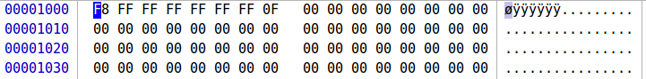
Cluster | Next Cluster
0x000 | 0xFF8
0x001 | 0xFFF
0x002 | 0xFFF
0x003 | 0xFFF
0x004 | 0xFFF
0x005 | 0xFFF

- Root Directory Structure
  - Sector 24 – 55
  - Byte 12,288 – 28,160
  - Address 0x3000 – 0x6E00
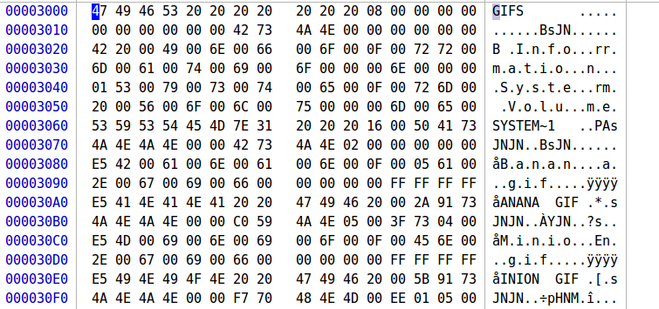
- Root Directory Entries
  - Banana
    - Status: 0xE5 – Deleted
    - Filename: Banana
    - Extension: GIF
    - Attribute: 0x20 – Archive
    - Modified date/time: 2/10/19 11:14 AM
    - Cluster: 0x0005 – 5
    - File Size: 0x0000280C – 291,647 bytes
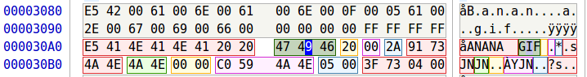
  - Minions
    - Status: 0xE5 – Deleted
    - Filename: Minion
    - Extension: GIF
    - Attribute: 0x20 – Archive
    - Modified date/time: 2/8/19 2:07 PM
    - Cluster: 0x007A – 77
    - File Size: 0x0000280C – 328,174 bytes
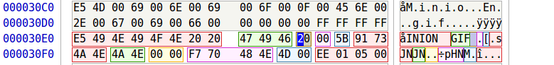

- File Recovery
Table 6 - FAT Partition 3 File Recovery
Filename | Cluster | File Length | Cluster Offset | File Offset | Actual Offset | Command To Retrieve File
Banana.GIF | 5 | 291647 | 12288 | 40960 | 205890560 | sudo dd if=fat.dd of='Banana.GIF' bs=1 skip=205890560 count=291647 status=progress
Minions.GIF | 77 | 328174 | 307200 | 335872 | 206185472 | sudo dd if=fat.dd of='Minions.GIF' bs=1 skip=206185472 count=328174 status=progress

3 NTFS Image
Using the same method, we used on the FAT volume we can find the partition sector offset and what partition type it is.
- First Sector: Offset 0x01C6 = 0x0800 = 2048
- First Sector Address: 512 * 2048 = 1,048,576 = 0x100000
- Partition ID: Offset 0x01C2 = 0x07 = 7 = NTFS
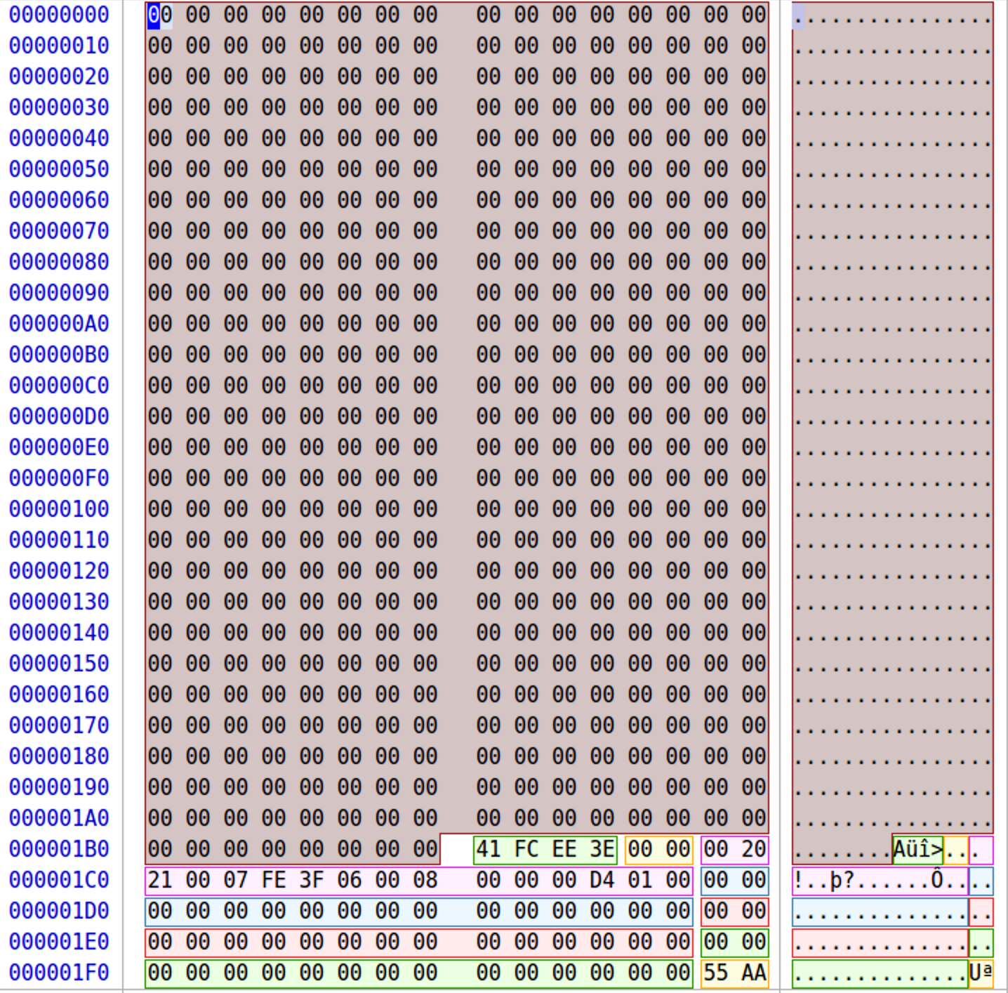

We now know the NTFS partition offset. We will use it later for recovering the files. However, we will not use the raw image in disk editor, due to the large offsets, we will use the partition view instead. Here we can grab the following information:
- Bytes/Sector: Offset 0x0B = 0x0200 = 512
- Sectors/Cluster: Offset 0x0D = 0x08 = 8
- Bytes/Cluster: 8 * 512 = 4096 bytes / cluster
- $MFT Cluster Number: Offset 0x30 = 0x1380 = 4,992
- $MFT Address: 0x13800000 = 20,447,232

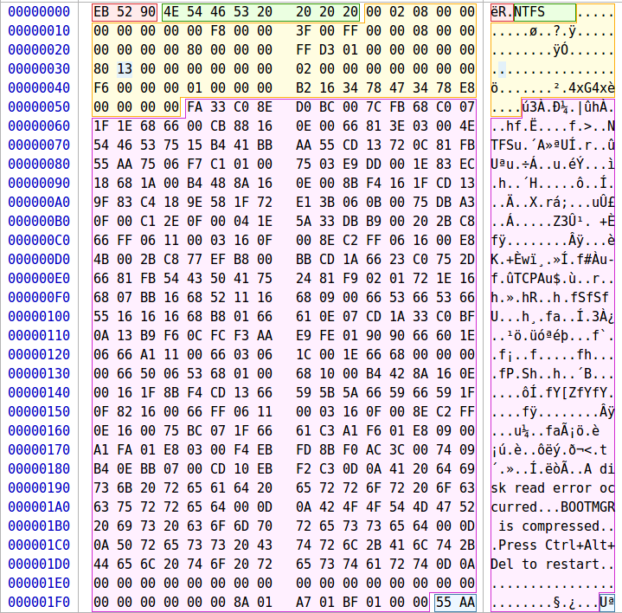
Figure 24 - NTFS MBR using FTK Imager

Now that we know where the Master File Table is located, we can find the number of system files, the system files length, and the start of the user files. To find the start of the user files, we simply add the $MFT Address to the system files length. We know that there are normally thirty-nine system files, so if we calculate the number of bytes for those system files we get that the system files take up 39,936 bytes (0x9C00) since each MFT entry is 1024 bytes. Adding that to the $MFT offset, 20,447,232 (0x1380000) we get that the user files start at 20,487,168 (0x1389C00). Each file entry should have at least the following file attributes
- $STANDARD_INFORMATION (0x10)
- $FILE_NAME (0x30)
- $DATA (0x80)
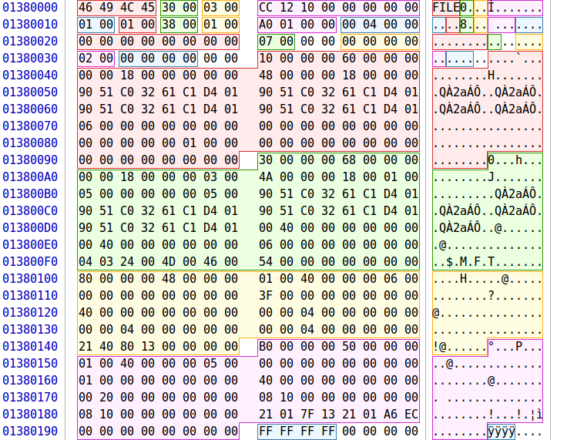

Jumping to offset 0x1389C00 we get the first user file.
- A Tale of Two Cities
  - List File Attributes:
    - 0x10 - $STANDARD_INFORMATION
    - 0x30 - $FILE_NAME
    - 0x80 - $DATA
    - 0xB0 - $BITMAP
  - Filename: Offset 0x0F2 = A Tale of Two Cities.pdf
- Allocated Size: Offset 0x150= 0x150000 = 1,376,256 bytes
- Deleted
- Data Start Cluster: Offset 0x170 = 0x0588 = 1,416
    - Data Start Address
      - 1,416 * 4,096 = 5,799,936
    - Actual Offset
      - Partition Offset + Start Address
      - 1,048,576 + 5,799,936= 6,848,512
- However, this file is fragmented, as seen by the multiple starting clusters. It cannot be recovered using the standard recovery method that we have been using
- Fragmented
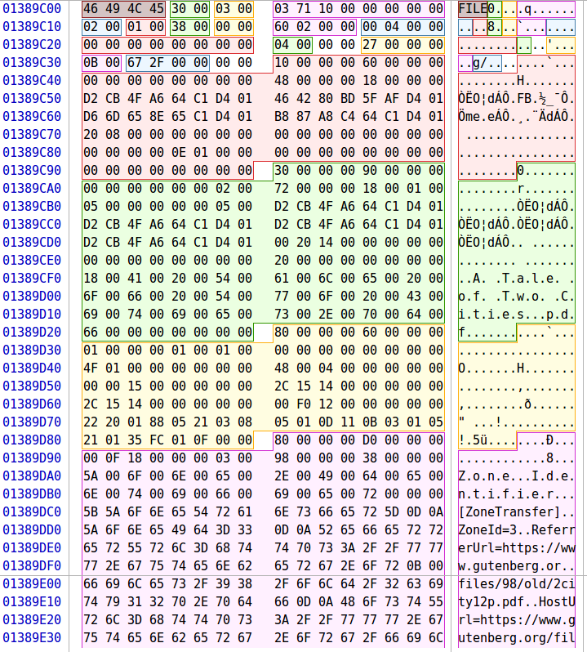

- Auburn
  - List File Attributes:
    - 0x10 - $STANDARD_INFORMATION
    - 0x30 - $FILE_NAME
    - 0x80 - $DATA
  - Filename: Offset 0x0F2 = Auburn.jpg
  - Active
  - Allocated Size: Offset 0x130 = 0x4000 = 16,384 bytes
  - Data Cluster Information
    - 21 04 CB 06
      - 2 bytes required for the first cluster address
      - Number of continuous clusters for this file – 1 * 4 = 4
      - Start Cluster for Data: 0x06CB = 1,739
      - Start Address for Data:
        - 1,739 * 4096 = 7,122,944
      - Actual Offset
        - Partition Offset + Start Address
        - 1,048,576 + 7,122,944 = 8,171,520
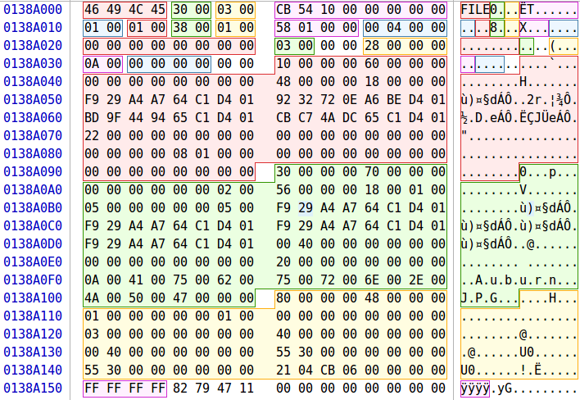

- Avengers – Offset 0x138A3C0 (20,489,216)
  - List File Attributes:
    - 0x10 - $STANDARD_INFORMATION
    - 0x30 - $FILE_NAME
    - 0x80 - $DATA
  - Filename: Offset 0x0F2 = Avengers.docx
  - Deleted
  - Allocated Size: Offset 0x138 = 0x100000 = 65,536 bytes
  - Data Cluster Information
    - 21 0D CF 06
      - 2 bytes required for the first cluster address
      - Number of continuous clusters for this file – 1 * D = 13
      - Start Cluster for Data: 0x06CF = 1,743
      - Start Address for Data:
        - 1,739 * 4096 = 7,139,328
      - Actual Offset
        - Partition Offset + Start Address
        - 1,048,576 + 7,139,328 = 8,187,904
  - Fragmented
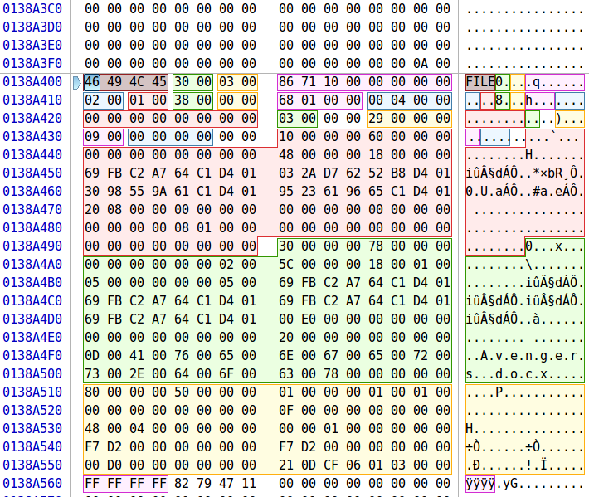

- Banana – Offset 0x138A800 (20,490,240)
  - List File Attributes:
    - 0x10 - $STANDARD_INFORMATION
    - 0x30 - $FILE_NAME
    - 0x80 - $DATA
    - 0xB0 - $BITMAP
  - Filename: Offset 0x0F2 = Banana.gif
  - Deleted
  - Allocated Size: Offset 0x130 = 0x048000= 294,912 bytes
  - Data Cluster Information
    - 21 48 DD 06
      - 2 bytes required for the first cluster address
      - Number of continuous clusters for this file – 0x1 * 0x48 = 72
      - Start Cluster for Data: 0x06DD = 1,757
      - Start Address for Data
        - 1,757 * 4096 = 7,196,672
      - Actual Offset
        - Partition Offset + Start Address
        - 1,048,576 + 7,196,672 = 8,245,248
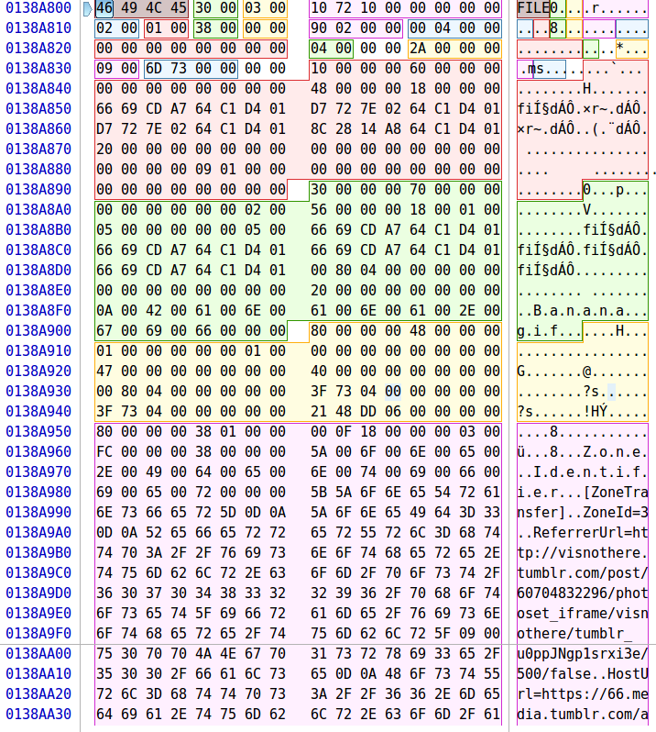
- Great Expectations – Offset 0x138AC00 (20,491,264)
  - List File Attributes:
    - 0x10 - $STANDARD_INFORMATION
    - 0x30 - $FILE_NAME
    - 0x80 - $DATA
    - 0xB0 - $BITMAP
  - Filename: Offset 0x0F2 = Great Expectations.pdf
  - Deleted
  - Allocated Size: Offset 0x148 = 0x310000= 3,211,264 bytes
  - Data Cluster Information
    - 21 03 86 0A
      - 2 bytes required for the first cluster address
      - Number of continuous clusters for this file – 0x1 * 0x3 = 3
      - Start Cluster for Data: 0x0A86 = 2,694
      - Start Address for Data:
        - 2,694 * 4096 = 11,034,624
      - Actual Offset
        - Partition Offset + Start Address
        - 1,048,576 + 11,034,624 = 12,083,200
  - Fragmented
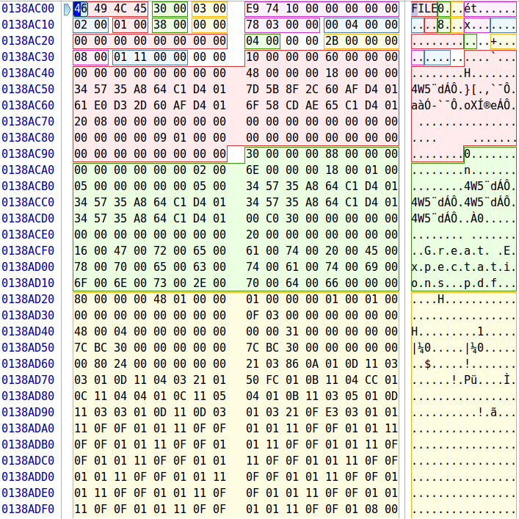

- Minion – Offset 0x138B000 (20,492,288)
  - List File Attributes:
    - 0x10 - $STANDARD_INFORMATION
    - 0x30 - $FILE_NAME
    - 0x80 - $DATA
    - 0x80 - $BITMAP
  - Filename: Offset 0x0F2 = Minion.gif
  - Allocated Size: Offset 0x130 = 0x051000 = 331,776 bytes
  - Deleted
  - Data Cluster Information
    - 21 05 31 0A
      - 2 bytes required for the first cluster address
      - Number of continuous clusters for this file – 0x1 * 0x5 = 5
      - Start Cluster for Data: 0x0A31 = 2,609
      - Start Address for Data:
        - 2,609 * 4096 = 10,686,464
      - Actual Offset
        - Partition Offset + Start Address
        - 1,048,576 + 10,686,464 = 11,735,040
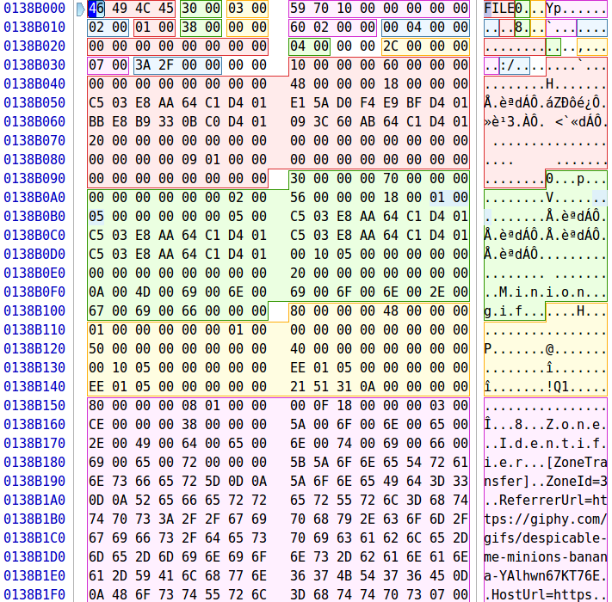
- War and Peace – Offset 0x138B000 (20,492,288)
  - List File Attributes:
    - 0x10 - $STANDARD_INFORMATION
    - 0x30 - $FILE_NAME
    - 0x80 - $DATA
    - 0x80 - $BITMAP
  - Filename: Offset 0x0F2 = War and Peace.pdf
  - Active
  - Allocated Size: Offset 0x140 = 0x9C0000 = 10,223,616 bytes
  - Data Cluster Information
    - 22 90 08 E0 1A
      - 2 bytes required for the first cluster address
      - 2 bytes required for cluster counter
        - 0x0890 = 2,192
      - Start Cluster for Data: 0x1AE0 = 6,880
      - Start Address for Data:
        - 6,880 * 4096 = 28,180,480
      - Actual Offset
        - Partition Offset + Start Address
        - 1,048,576 + 28,180,480 = 29,229,056
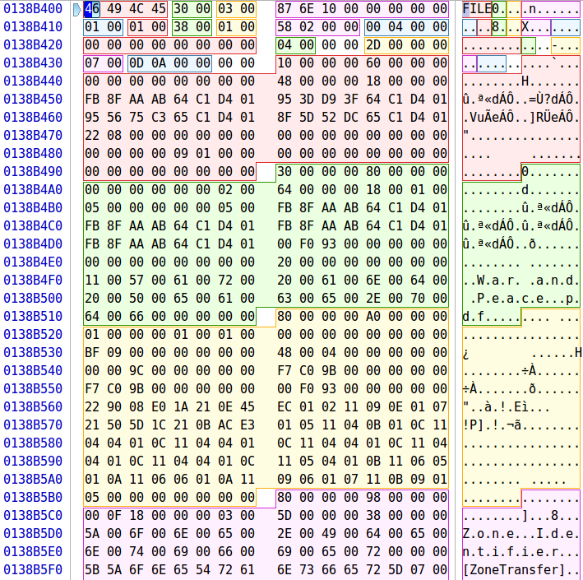

Using the information gathered we can make a table similar to the ones we used for the FAT partitions. However, this time clusters are not subtracted by two. Note that some of these files are fragmented and cannot be recovered in the same process we have been using so we will have to use sleuth kit instead.
Filename | Cluster | File Length | Cluster Offset | Actual Offset | Command To Retrieve File | Recoverable with DD
A Tale of Two Cities.pdf | 1,416 | 1,376,256 | 5,799,936 | 6,848,512 | sudo dd if=fat.dd of='A Tale of Two Cities.pdf' bs=1 skip=6848512 count=1376256 status=progress
Auburn.jpg | 1,739 | 16,384 | 7,122,944 | 8,171,520 | sudo dd if=fat.dd of='Auburn.jpg' bs=1 skip=8171520 count=16384 status=progress | X
Avengers.docx | 1,743 | 65,536 | 7,139,328 | 8,187,904 | sudo dd if=fat.dd of='Avengers.docx' bs=1 skip=8187904 count=65536 status=progress
Banana.gif | 1,757 | 294,912 | 7,196,672 | 8,245,248 | sudo dd if=fat.dd of='Banana.gif' bs=1 skip=8245248 count=294912 status=progress | X
Great Expectations.pdf | 2,694 | 3,211,264 | 11,034,624 | 12,083,200 | sudo dd if=fat.dd of='Great Expectations.pdf' bs=1 skip=12083200 count=3211264 status=progress
Minion.gif | 2,609 | 331,776 | 10,686,464 | 11,735,040 | sudo dd if=fat.dd of='Minion.gif' bs=1 skip=11735040 count=331776 status=progress | X
War and Peace.pdf | 6,880 | 10,223,616 | 28,180,480 | 29,229,056 | sudo dd if=fat.dd of='War and Peace.pdf' bs=1 skip=29229056 count=10223616 status=progress | X
Table 7 - NTFS File Recovery
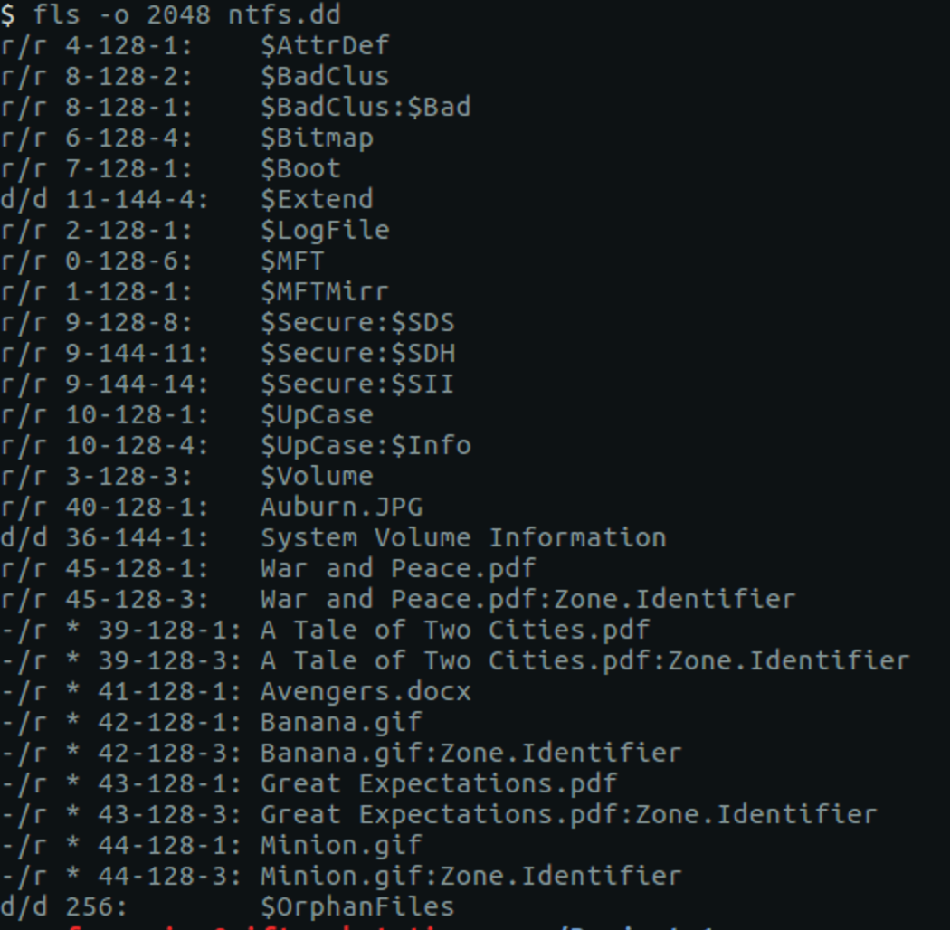
Using sleuth kit we can recover the files. However, similar to before we will need the inodes of these files first. To gather them we will need to run fls -o 2048 ntfs.dd.
Figure 25 - File Fragmentation Recovery
With the inodes we can now attempt to recover the files. We can use icat to recover these files.

icat -o 2048 -r ntfs.dd [inode] > [filename]
- icat -o 2048 -r ntfs.dd 39-128-1 > ‘A Tale of Two Cities.pdf’
- icat -o 2048 -r ntfs.dd 41-128-1 > ‘Avengers.docx’
- icat -o 2048 -r ntfs.dd 43-128-1 > ‘Great Expectations.pdf’

5 Conclusion
This project allowed us to delve into a FAT and a NTFS file system. In doing so, we gained a better understanding of how the formats are structured, where data is stored, and how the file systems take care of deleted files.
Number of FAT Partitions: 3
Number of Active and Deleted Files per Partition (FAT):
SEC Pics: 4 Active and 3 Deleted
Classics: 1 Active and 3 Deleted
GIFs: 2 Deleted Gifs
Number of NTFS Image Partitions: 1
Number of NTFS Active and Deleted files: 2 Active and 5 Deleted

6 References
[1] https://en.wikipedia.org/wiki/Design_of_the_FAT_file_system

Sectors are usually 512 bytes, sometimes 4096. One can see exactly how big a sector is in the partition’s reserved area

